# Cart

## View cart

Once member logged in, click “Cart” button next to search game bar in the navigation bar.

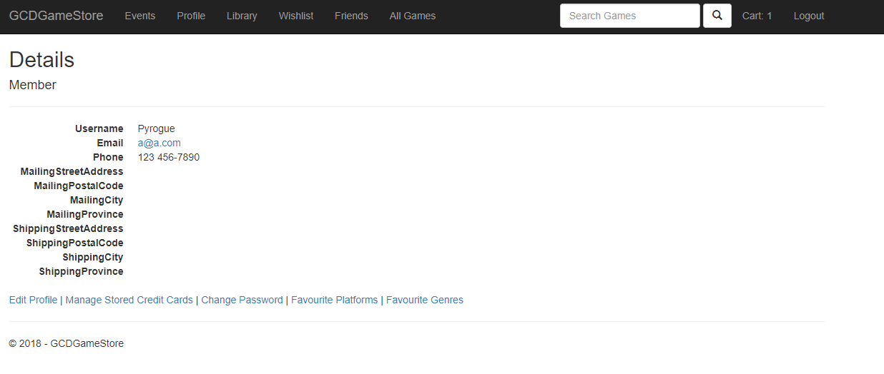

The cart page is displayed.

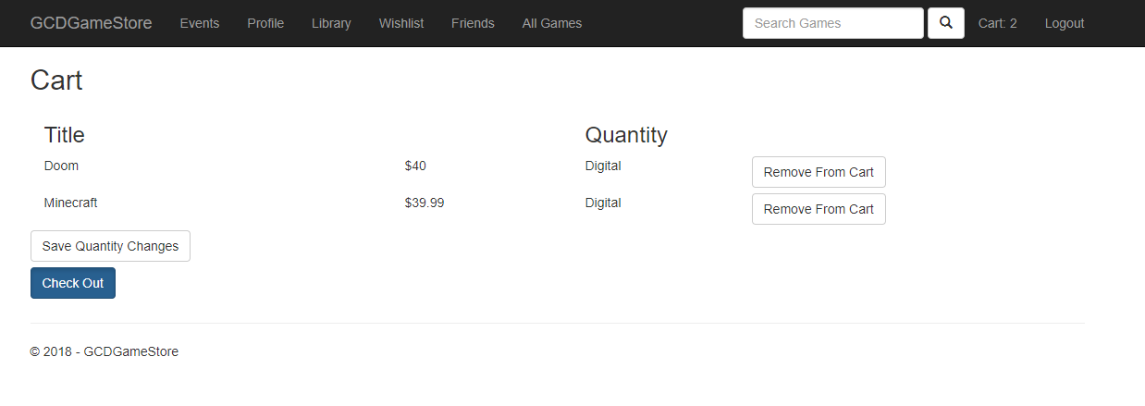

## Edit Cart

In the cart page, enter a number in the quantity to edit the number of physical copies. Click “Save Quantity Changes” to finish editing cart.

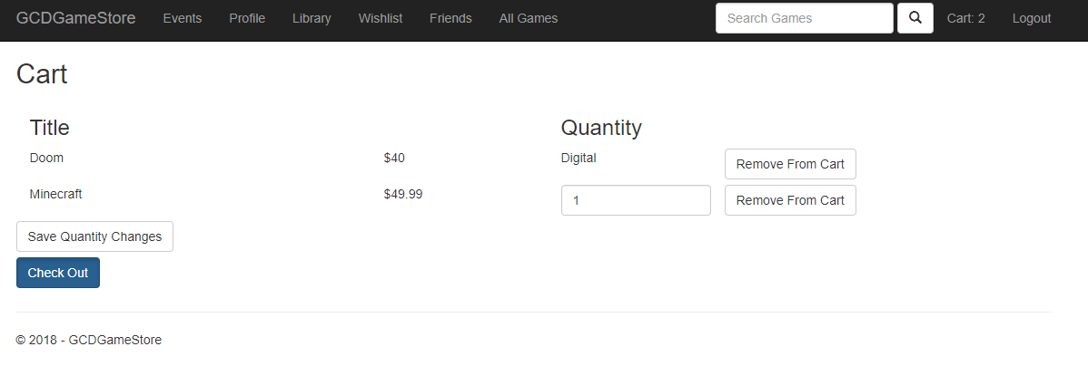

Updated cart is displayed.

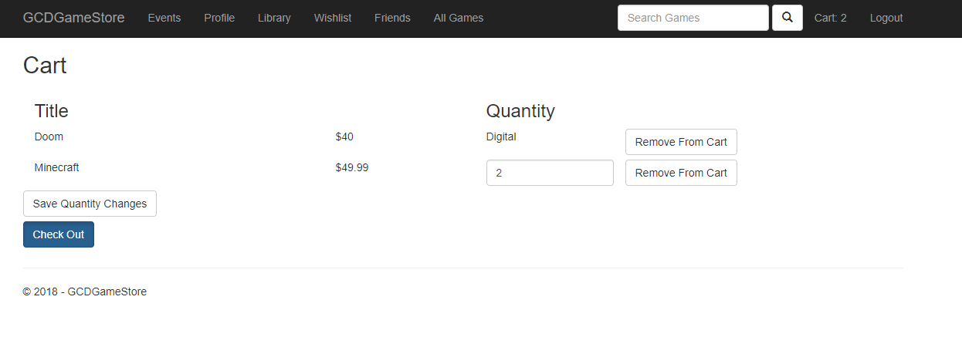

## Check Out

In the cart page, click “Check out” button to confirm order before payment.



Checkout detail is displayed.

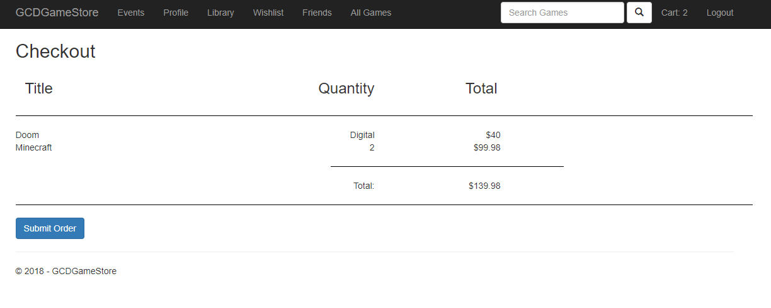

## Submit order

In the checkout page, click “Submit Order” button to submit this order.



Once the submission is successful, the library page will be displayed, and the bought game will be showed.

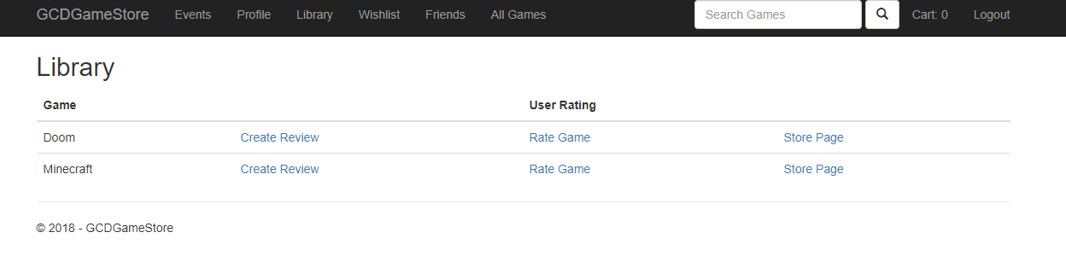

## View Friends

Once logged in, click the “Friends” button in the navigation bar.

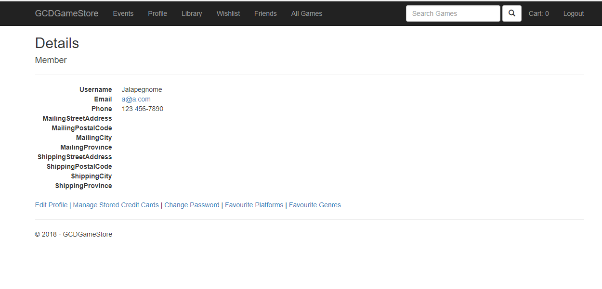

The friends list is displayed.

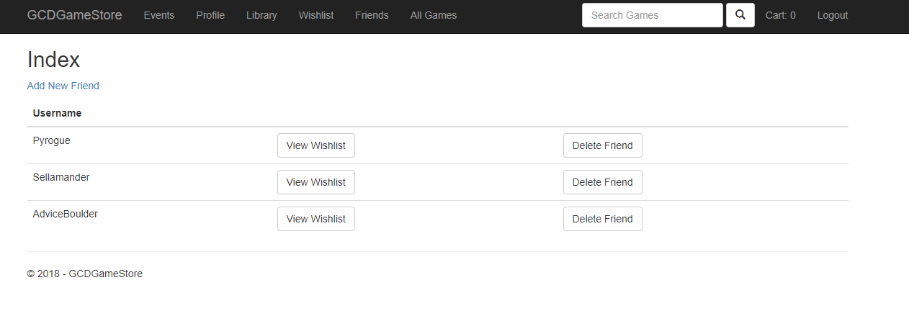

## Add Friend

In the friends list page, click “Add New Friend” to go create friend page.



In create friend page, enter the member’s name to add to the friend list, and then click “Create” button to finish adding friend.

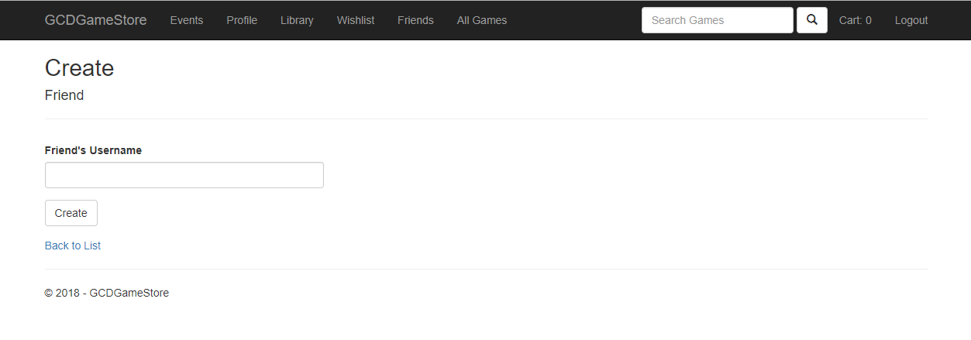Once the friend is added, the friend list page will be loaded.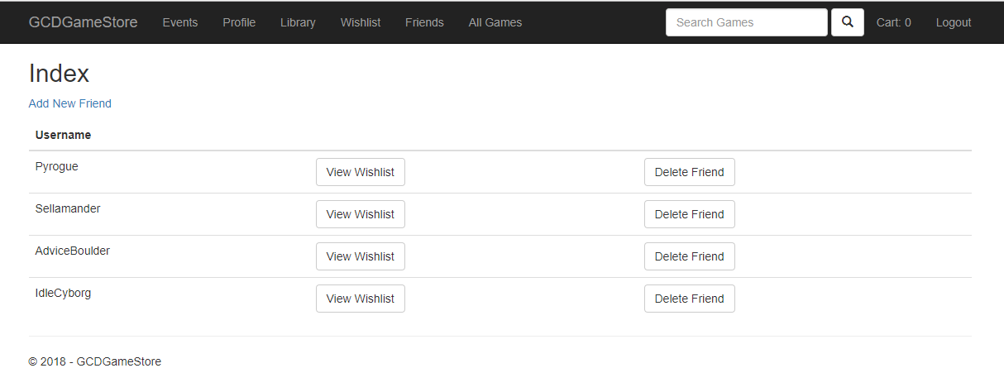

## Delete friend

In the friend list page, click the “Delete Friend” button to remove one friend from the friend list.



The friend has been removed from the list, and the updated friend list page is displayed.

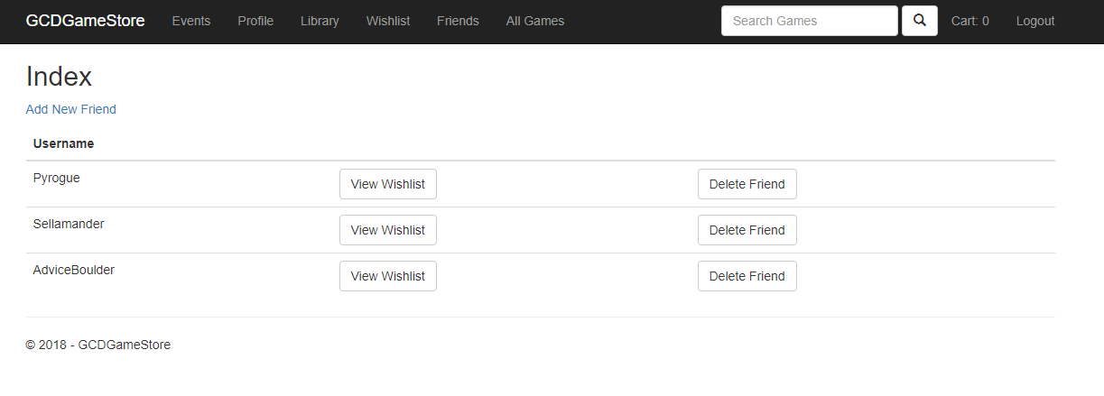

## View friend’s wish list

In the friend list page, click “View Wishlist” button for view one friend’s wish list.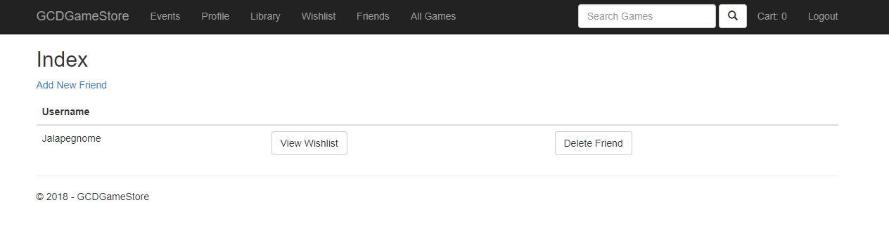

The page display Jalapegnome’s wishlist.

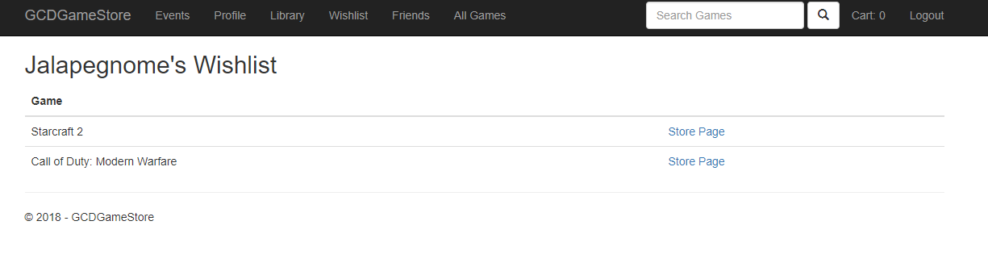

# Library

## Rate game

Once member logged in, Click “Library” button in the navigation bar to go library page.



In library page, the member’s game list displayed, click “Rate Game” for rating Doom. Rating game page will be displayed.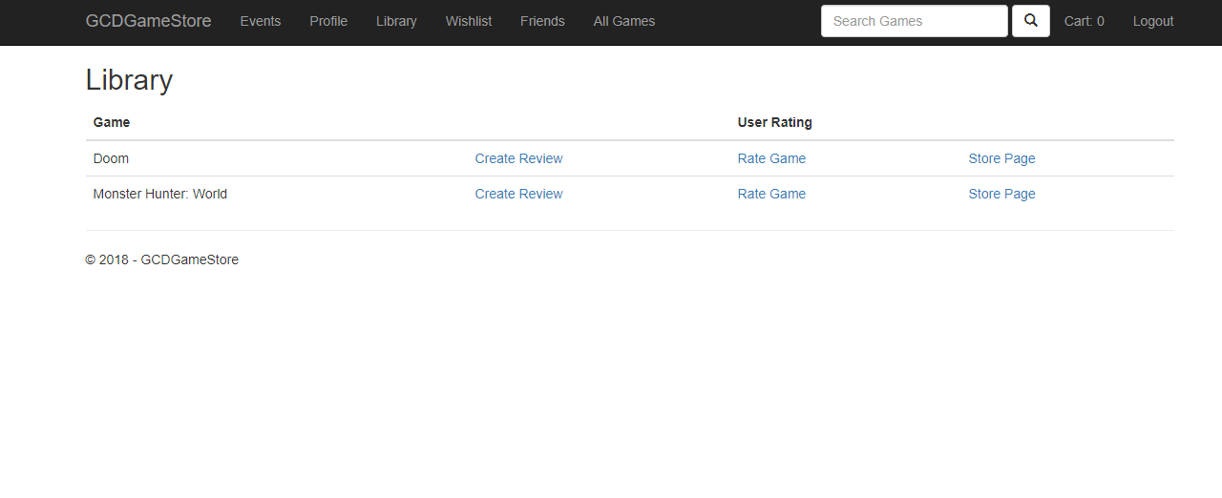

In rating game page, enter any number between 1 to 5, and click “Create” button. Member add a rating for game Doom, and library page will be returned with the rating number.

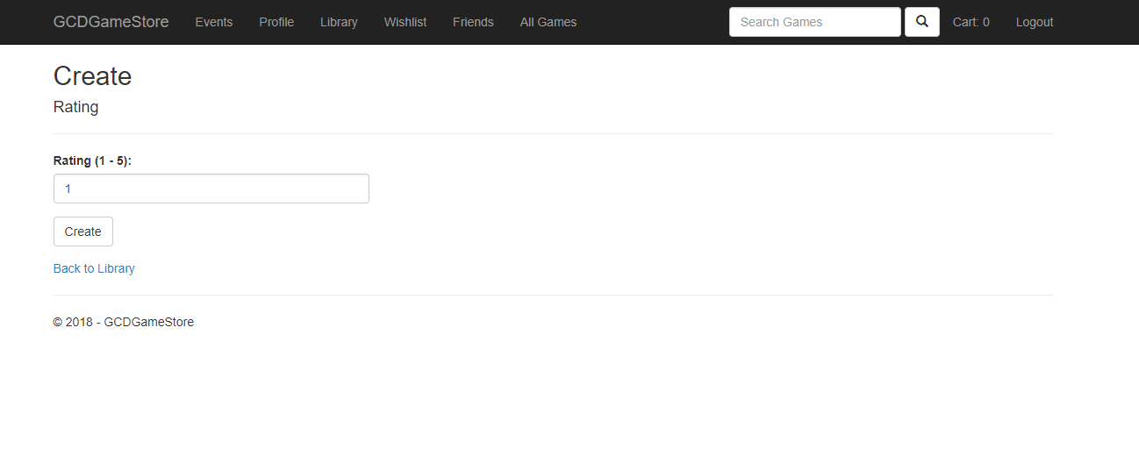The library page is displayed and the in user rating for Doom is changed to 2.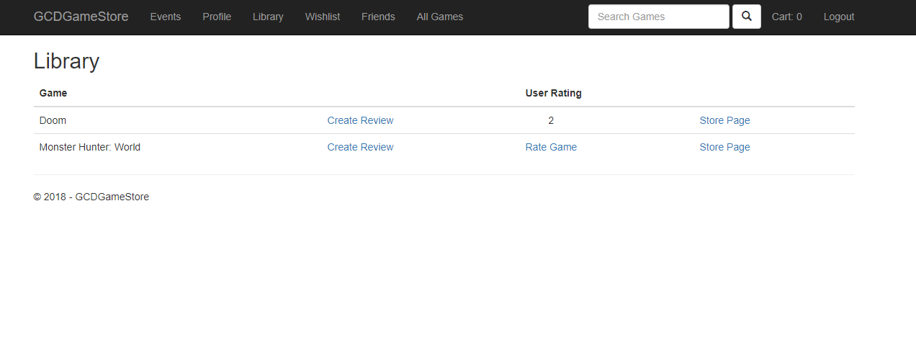

## Add review

Continue with the library page, click “Create Review” for Doom to go create review page.



In create review page, check “Recommended”, if the game is recommended. Entering the review in “ReviewText”, then click “Create” button to finish adding review. The review detail is displayed.

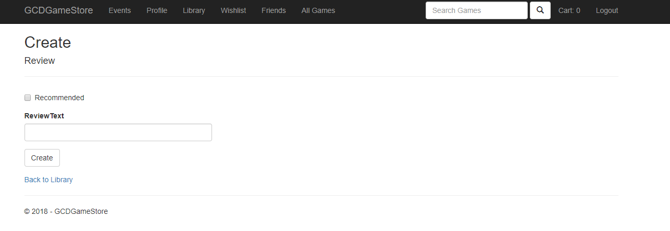

The review detail of Doom return.

